Aim: To Implement Continuous Integration with Version Control
Software / Hardware Requirements:
- Computer with Windows OS
- Internet Connection
- Git installed (in your system)
- GitHub Account (Valid Mail ID and Username)
- Python editor (Idle, Pycharm etc)
- Text Editor (Notepad, NodeJS etc)
Files Required:
Python File: Create a Python file with basic code and Test case
def add(a, b):
return a + b

def test_add():
assert add(2, 3) == 5

#checks whether add function works correctly, if equals 5 – Test Passes else – Assertion Error

YAML File: Defines Workflow (like a Bike or Mobile Manual)

name: Python Test

on: [push]

jobs:
test:
runs-on: ubuntu-latest

steps:
- name: Checkout code
uses: actions/checkout@v4

- name: Set up Python
uses: actions/setup-python@v5
with:
python-version: "3.10"

- name: Run test
run: python main.py

# on:[Push] – runs when code is pushed
# jobs: - defines work

Git Installation:

In CMD, run
git –version # if present display version else shows error

# if not present visit https:git-scm.com and install

GitHub Account & Repository Creation:

Register through your gmail ID in github Website, You will be given a User ID. Create a repository by clicking “+” icon and give a name to remote repository.

Algorithm:

- Initialize Git Repository (Local Version Control Setup). Create a project folder. Open terminal and navigate to the folder. Run: git init
- Create a simple Python file (example: app.py) with basic code and a test case
- Configure your mail ID and User Name. Run: git config –global user.email “mail ID”. Run: git config –global user.name “user ID”. Run: git remote –v (Displays configured accounts)
- Push to Remote Repository (GitHub Integration). Create a new repository on GitHub (“eg. bsr”). Link local repository (project folder. This is local repository) to github repository (This is a remote repository). Run: git remote add origin “github remote repository url”.
- Create a directory/folder with name “.github”. Run: mkdir .github. Navigate to that folder. Run: cd .github. Again create a folder with name “workflows”. Run: mkdir workflows. Navigate into it. Run: cd workflows
- In workflows folder, create a YAML file. Run: type nul > bsr.yml (“Here bsr is the name of github remote repository). Copy and paste the YAML content into this file by opening it save and close
- Come back to project folder. Run: cd.. (2 times here)
- Run: git branch –M main. Run: git push –u origin main
- Stage and commit changes. Run: git add . and Run: git commit -m "Initial Commit”
- Run: git push
- Visit github, therein actions tab, click to see the pipeline triggered. Observe results. Success if all test cases passes. Fail if any failed testcase.

Commands Sequence:

Microsoft Windows [Version 10.0.26100.7462]
(c) Microsoft Corporation. All rights reserved.

C:\Users\ACER>e:

E:\>cd bsr

E:\bsr>git init
Reinitialized existing Git repository in E:/bsr/.git/

E:\bsr>git remote -v
origin https://github.com/bskrmtech-code/bsr (fetch)
origin https://github.com/bskrmtech-code/bsr (push)

E:\bsr>git remote add origin https://github.com/bskrmtech-code/bsr
error: remote origin already exists.

E:\bsr>git config --global user.name bskrmtech-code

E:\bsr>git config --global user.mail bskr.mtech@gmail.com

E:\bsr>cd .github

E:\bsr\.github>cd workflows

E:\bsr\.github\workflows>type nul > bsr.yml

E:\bsr\.github\workflows>cd..

E:\bsr\.github>cd..

E:\bsr>git branch -M main

E:\bsr>git push -u origin main
branch 'main' set up to track 'origin/main'.
Everything up-to-date

E:\bsr>git add .

E:\bsr>git commit -m "hi"
[main 17f3ce8] hi
1 file changed, 0 insertions(+), 0 deletions(-)
create mode 100644 .github/workflows/bsk.yml

E:\bsr>git push
Enumerating objects: 8, done.
Counting objects: 100% (8/8), done.
Delta compression using up to 4 threads
Compressing objects: 100% (3/3), done.
Writing objects: 100% (5/5), 419 bytes | 419.00 KiB/s, done.
Total 5 (delta 0), reused 0 (delta 0), pack-reused 0 (from 0)
To https://github.com/bskrmtech-code/bsr
302af9f..17f3ce8 main -> main

E:\bsr>

Result: The experiment was successfully completed, and Continuous Integration (CI) pipeline was implemented

Basic git Commands:
Command | Purpose
git init | Initialize a new Git repository
git clone <url> | Copy a remote repository to local system
git status | Show current state of files (tracked/untracked)
git add <file> | Stage a specific file for commit
git add . | Stage all changed files
git commit -m "message" | Save changes to local repository
git log | View commit history
git diff | Show changes between versions
git branch | List branches
git branch <name> | Create a new branch
git checkout <branch> | Switch to another branch
git checkout -b <name> | Create and switch to a new branch
git merge <branch> | Merge another branch into current branch
git remote add origin <url> | Connect local repo to GitHub
git push origin main | Upload local commits to GitHub
git pull origin main | Download updates from GitHub
git fetch | Get updates without merging
git reset <file> | Unstage a file
git reset --hard | Discard all local changes
git rm <file> | Remove file from repository
git stash | Temporarily save uncommitted changes
git stash pop | Restore stashed changes
git tag | Create a version tag

CONFIG → INIT → CREATE → ADD → COMMIT → BRANCH → REMOTE → PUSH

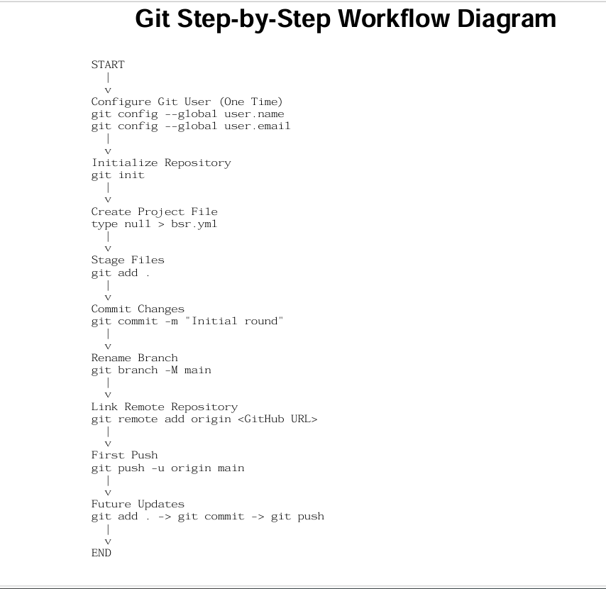

Summary:
- To check if git installed. Run git –version
- To see linked repositories if any. Run: git remote –v
- To see if mail and user id are configured. Run git config –list.
- To configure above. Run; git config --global user.name “User ID”. Run: git config --global user.mail “ Mail ID”. These are from github account.
- To create an empty yml file. Run: type nul > “file name.yml”.
- To link local repository(git) and remote repository(github). Run: git remote add origin “github repo url”
- To delink local repo with remote repo. Run git remote remove origin

